Name and description****

**Name:** Re:Discover

**Description**: An exploration based application which will help the user on visiting points of interest, historical places, and elements worth of note in any city they're interested about, in a way that will actively engage them by using notable aspects of software gamification.

**Narrative:** The world is obscured by the Abyss, a dangerous influence who threatens to throw it into oblivion for eternity, YOU, are the traveler, armed with your lantern, will shine light on to the most forgotten and darkened places to bring them to the surface of knowledge again.

With the light of the culture the traveler will unlock the places along his path blessing them by granting them the power to fight back the Abyss, until all the city is free from this influence.

**Why should you use this app?**

**Problem Statement:**

Current city guides for tourists primarily offer non-gamified virtual planning tools that dictate a fixed route. This approach limits visitor freedom and independence.

Furthermore, existing solutions fail to address the needs of:

1. **Busy Professionals:** Who often lack the time for extensive planning and prefer a relaxing, spontaneous experience.
2. **Culture-Conscious Travelers:** Who frequently leave a city regretting the omission of high-cultural value Points of Interest (POIs).
3. **Teens:** Who are often not interested in learning and exploring the beautiful aspects of a city

**Proposed Solution:**

Our approach aims to overcome these limitations by offering tourists increased freedom and independence through diverse visit modes. The goal is to create an experience that is accessible and engaging for all age groups, including teens and older people, while also catering to the spontaneity preferred by busy workers. We aim to ensure a comprehensive cultural experience that minimizes the risk of missing key POIs.

**Supporting Evidence:**

We conducted a state-of-the-art analysis of various products to identify their strengths and weaknesses. Notable examples include:

* <https://www.visartech.com/portfolio/explorr-gamified-traveling/>
* <https://www.visitacity.com/>
* <https://www.n-gage.io/attraction-management-software-mobile-app>

A significant challenge was the lack of publicly available details regarding the implementation or usage of these products. Consequently, we were only able to extract the "virtual city guides" concept, which we plan to integrate as a core feature within our application.

Context

Domain

* **Domain:** Education / Learning
* **Domain description:** An exploration based application which will help the tourist on visiting points of interest, historical places, and elements worth of note in any city they're interested about, in a way that will actively engage them using notable aspects of software gamification.

## Aim

## The goals of many gamification projects do not appear to have been clearly set out before the projects began. The goal of a gamified solution may simply be to increase the number of students, to increase the cooperation among users, or simply to support a behavior change towards eco-sustainable behaviors. In order to help researchers and practitioners in the reasoning underlying the design and development of software, the aim component collects information about the goal of the designed software and why it has been thought of. This selection includes three different types of aims, reported by Tondello, Premsukh, and Nacke, 2018:

## (1) Outcome goal, which refers to the accomplishment of a very specific result. For example, many goals involve completing specific tasks; therefore, the result is well-defined. Challenges, quests, and exploratory tasks are well suited to define outcome goals;

## (2) Performance goal, which refers to doing well by one’s own performance standards. For example, earning a specific number of points, reaching a specific position in a leaderboard, or completing a specific number of tasks;

## (3) Process or Learning goal is related to learning new skills. Research has shown that when the individual lacks the necessary skills or knowledge to accomplish a difficult goal, it is better to set a learning goal instead of an outcome or a performance goal.

* **Aim:** Process/learning
* **Aim description:** The core purpose of our application is to transform the tourist experience. It aims to alleviate the stress of planning and the fear of missing a city's essential Points of Interest, while simultaneously engaging teenagers who typically show less enthusiasm for cultural activities.

## Encouraged Behaviours

## Game behavior component refers to the clarification of the game rules, game mechanics, game progression. The game rules determine, just like in any other game, how the game inside the application is played. The mechanics describe what happens when a player does something in the game in order to achieve the game’s goal. Progression is defined through a subset of game mechanics that describe how the game overall progresses like, for example, player levels advancing and, thereby, unlocking new things for the game. The final output consists of a list of the game rules, in which mechanics and progression are specified. Moreover, this part is linked to the dynamics subcomponent, which provides a list of possible dynamics that can emerge runtime or after a certain number of runs. This allows researchers and practitioners to (1) monitor the interaction between users and mechanics, and (2) to modify the design in order to avoid inadequate interactions and behaviors.

* **Encouraged Behaviours:** a learn-focused approach is adopted for towns’ historical storytelling, encouraging passion, curiosity and also respect and cooperation among users, to protect POIs giving them more relevance
* **Discouraged Behaviours:** toxical relationships between users; griefing POIs; bugs / glitches abusing to earn more XP, levels, cosmetics or badges than intended; use of any kind of third-party tools (injection, bots…) to falsify the GPS location, earn more XP, levels, cosmetics or badges.

## Target user

## Several documents in the gamification field suggest that users’ individual differences and preferences are crucial for the success of gamified solutions (B. Kim, 2015; Koivisto & Hamari, 2019; Tondello et al., 2016; Zahedi et al., 2021). The existing taxonomies take into account the personality traits or the possible user type. Thus, we decided to develop our taxonomy, following the possible users’ category. The target users component collects all the relevant data related to the users who will be involved in the use of the software (category and age ranges) The difficulty in the development of a possible exhaustive taxonomy could lead to explorative applications of gamified solutions for studying new categories.

**Tourists**:

* **Age 14-17**: Teenagers on family holidays or school excursions. They could be better engaged and encouraged to learn through a more "gamified" experience that blends fun with educational content.
* **Age 18-29**: Young adults, often students or early career professionals, traveling with friends or partners. While they are competent navigators and planners, they are drawn to engaging, non-traditional experiences. They appreciate the gamified elements not for necessary guidance, but as a fun, competitive, and social layer that enhances a planned trip with friends, making exploration an enjoyable group activity or challenge.
* **Age 30-39:** Working professionals, often traveling with friends or partners, with established planning habits. The gamified approach is less powerful for basic engagement and more focused on providing **easy, enjoyable city exploration** and enhancing the social experience with friends. It serves as a seamless tool for discovery, not necessarily demanding competitive challenges or focused "play."
* **Age 40-59:** Parents traveling with their children (14+ age range) or groups of friends.
  + For the sub-group with children, the gamified approach is highly valuable as a tool for shared learning and bonding. It provides a structured, engaging way to "play" together, encouraging both parent and child to discover and learn about POIs, turning the city exploration into a collaborative family quest.
  + For groups of friends, the gamified layer is driven more by initial curiosity. They might explore various modes but tend to use the app primarily for information and discovery, with the gamification serving as a light, optional layer rather than a central focus for competition or achievement hunting. They appreciate a balance of deep cultural information and engaging, achievement-based mechanics, but the gamified element is less sustained than for families.
* **Age 60-80:** Seniors primarily use the app as a reliable, accessible cultural guide (large text, simple navigation, deep content), driven by a strong interest in learning and exploration. Gamification is optional and reduced, focusing on non-competitive elements like Completed Path tracking and brief Knowledge Quizzes for learning reinforcement.

When with grandchildren, the interaction is often **co-guided**: the grandchild influences the grandparent's engagement with the app's gamified elements, but the senior remains the ultimate leader, using the gamification for **intergenerational learning** and sharing the experience.

**Why should you use this app?**

**Problem Statement:**

Current city guides for tourists primarily offer non-gamified virtual planning tools that dictate a fixed route. This approach limits visitor freedom and independence.

Furthermore, existing solutions fail to address the needs of:

1. **Busy Professionals:** Who often lack the time for extensive planning and prefer a relaxing, spontaneous experience.
2. **Culture-Conscious Travelers:** Who frequently leave a city regretting the omission of high-cultural value Points of Interest (POIs).
3. **Teens:** Who are often not interested in learning and exploring the beautiful aspects of a city

**Proposed Solution:**

Our approach aims to overcome these limitations by offering tourists increased freedom and independence through diverse visit modes. The goal is to create an experience that is accessible and engaging for all age groups, including teens and older people, while also catering to the spontaneity preferred by busy workers. We aim to ensure a comprehensive cultural experience that minimizes the risk of missing key POIs.

**Supporting Evidence:**

We conducted a state-of-the-art analysis of various products to identify their strengths and weaknesses. Notable examples include:

* <https://www.visartech.com/portfolio/explorr-gamified-traveling/>
* <https://www.visitacity.com/>
* <https://www.n-gage.io/attraction-management-software-mobile-app>

A significant challenge was the lack of publicly available details regarding the implementation or usage of these products. Consequently, we were only able to extract the "virtual city guides" concept, which we plan to integrate as a core feature within our application.

Similiar apps

**Duolingo**

|  |  |  |
| --- | --- | --- |
|  | **Reply to Questions** | **<- Questions to Ask** |
| **Mechanics** | Experience points (XP), levels, hearts (lives), daily streak, rewards, gems, leaderboards, challenges, interactive lessons with instant feedback. | What game elements are used? |
| **Dynamics** | Users learn through micro-lessons and quick interactions. Scoring and streak mechanics incentivise consistency. Leaderboards create friendly competition. Users can unlock content and customise their own path. | How do users interact with these mechanics? |
| **Aesthetics** | Fun, colourful, motivating and light-hearted experience. Stimulates a sense of progress, satisfaction and challenge. Mascots (such as Duo) add empathy and humour. | What feelings or experiences are evoked? |
| **Target Audience** | People of all ages who want to learn a language in a free, playful and accessible way. Widely used by students, travellers and self-taught people. | Who are the users? |
| **Purpose / Domain** | Promoting language learning through gamification and making education accessible and engaging for all. | What goal or problem does it address? |
| **Pain Points / Gaps** | Repetitiveness of lessons, lack of real conversations, limited approach to grammar, reliance on gamification rather than real language understanding. | What’s missing or not working? |

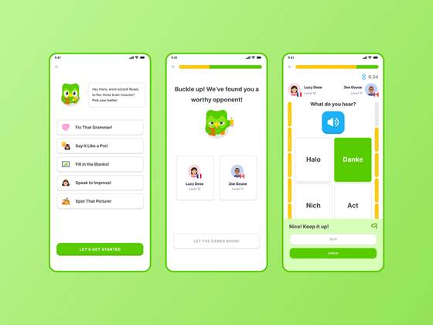

Quiz and initial questions to the user

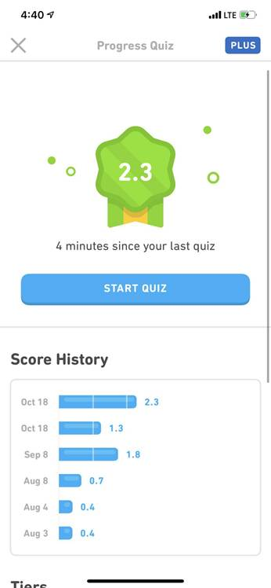

progression and points

**Genshin Impact**

|  |  |  |
| --- | --- | --- |
|  | **Reply to Questions** | **<- Questions to Ask** |
| **Mechanics** | Exploration-based mechanics: players unlock regions by reaching and activating Statues of The Seven, which reveal parts of the map. Collectibles (like Anemoculi/Geoculi), stamina upgrades, quests, and teleport waypoints reinforce exploration. Combat, elemental reactions, character progression, and gacha systems are also core mechanics. | What game elements are used? |
| **Dynamics** | Players are encouraged to explore the world to progress — unlocking the map grants fast travel, resources, and story advancement. The mechanics reward curiosity and gradual mastery of terrain. Players interact through climbing, gliding, combat, and puzzle-solving. | How do users interact with these mechanics? |
| **Aesthetics** | Evokes a strong sense of wonder, freedom, and discovery. Each unlocked area feels rewarding, often revealing stunning scenery, lore, and secrets. The gradual map reveal provides a feeling of progression and immersion. | What feelings or experiences are evoked? |
| **Target Audience** | Players who enjoy open-world RPGs, exploration, adventure, and narrative-driven experiences. The audience includes casual players attracted by visuals and completionists drawn to exploration and collection. | Who are the users? |
| **Purpose / Domain** | To create an engaging exploration experience that motivates players to discover the world organically. The map unlocking mechanic structures player progression and controls difficulty and pacing. | What goal or problem does it address? |
| **Pain Points / Gaps** | Map unlocking can feel repetitive over time; travel between regions may become slow without teleportation points. Some areas are gated by story progress, limiting free exploration. Also, new players may find the map overwhelming in scale. | What’s missing or not working? |

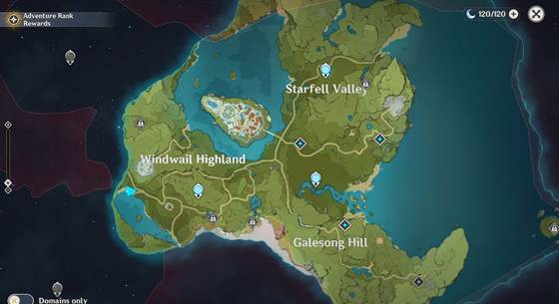

Example of obfuscated map to unlock

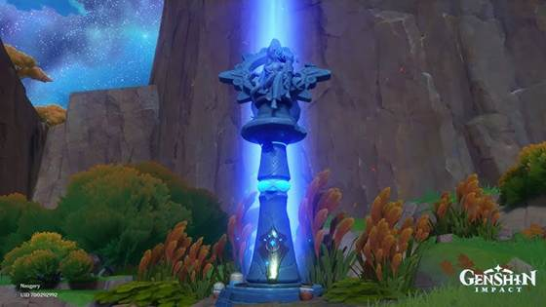

Unlock system

**Geocaching**

|  |  |  |
| --- | --- | --- |
|  | **Reply to Questions** | **<- Questions to Ask** |
| **Mechanics** | Players use GPS coordinates to locate hidden “geocaches” in the real world. Each cache has a description, hints, and coordinates. Game elements include maps, logs, clues, collectibles, badges, and community challenges. | What game elements are used? |
| **Dynamics** | Users navigate using GPS and interpret descriptions or riddles to find real-world locations. The gameplay encourages exploration, problem-solving, and community participation through sharing finds and hiding new caches. | How do users interact with these mechanics? |
| **Aesthetics** | Evokes a sense of adventure, curiosity, and achievement. Finding a cache gives satisfaction similar to a treasure hunt. Encourages connection with nature, travel, and discovery of hidden places. | What feelings or experiences are evoked? |
| **Target Audience** | Outdoor enthusiasts, explorers, families, travelers, and players who enjoy treasure hunts or location-based experiences. Also used by educators for experiential learning. | Who are the users? |
| **Purpose / Domain** | To promote exploration and discovery through real-world interaction. Combines digital clues with physical environments, encouraging physical activity and curiosity about surroundings. | What goal or problem does it address? |
| **Pain Points / Gaps** | Requires GPS and physical mobility, limiting accessibility. Some caches may be poorly maintained or missing. Focuses on physical objects rather than cultural or educational content; lacks narrative or descriptive depth. | What’s missing or not working? |

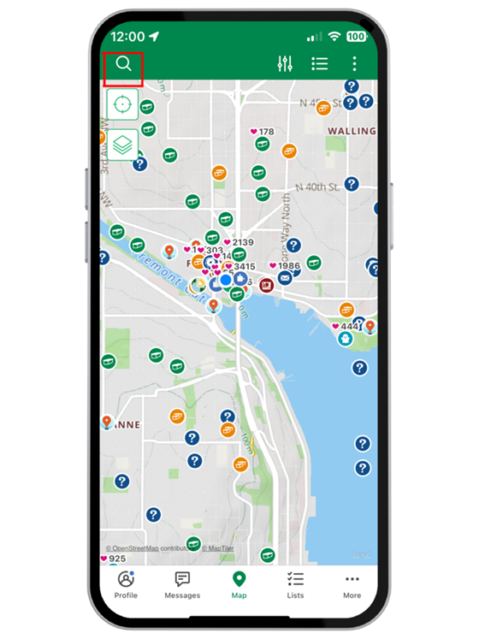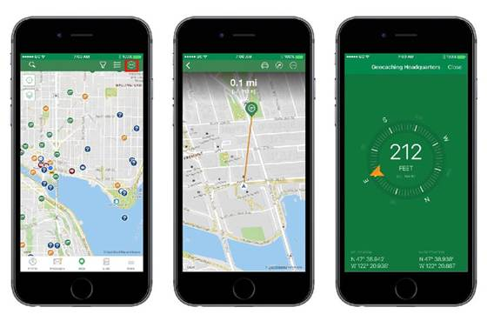

**Google Maps**

|  |  |  |
| --- | --- | --- |
|  | **Reply to Questions** | **<- Questions to Ask** |
| **Mechanics** | Interactive world map with zoom, navigation, location pins, search, route planning, and suggestions. Includes features like Street View, reviews, photos, ratings, saved places, and personalized recommendations. | What game elements are used? |
| **Dynamics** | Users interact by searching, exploring, and navigating to locations. They can discover new POIs (monuments, restaurants, attractions) via recommendations or user-generated content. The app uses data and algorithms to adapt suggestions based on behavior and location. | How do users interact with these mechanics? |
| **Aesthetics** | Evokes a sense of orientation, exploration, and practicality. Offers satisfaction through discovery, planning, and efficient movement. Visual clarity and usability create a sense of control and trust. | What feelings or experiences are evoked? |
| **Target Audience** | Anyone who travels, explores, or needs navigation — tourists, commuters, travelers, and local users seeking new places. Broad demographic due to accessibility and integration with daily life. | Who are the users? |
| **Purpose / Domain** | To provide accurate geolocation, navigation, and discovery tools. Helps users find routes, explore cities, and identify points of interest or activities nearby. | What goal or problem does it address? |
| **Pain Points / Gaps** | Focused mainly on navigation and data rather than storytelling or gamified discovery. Recommendations can feel generic or algorithm-driven, lacking personalized cultural depth. Limited interactive learning about monuments or history beyond basic info. | What’s missing or not working? |

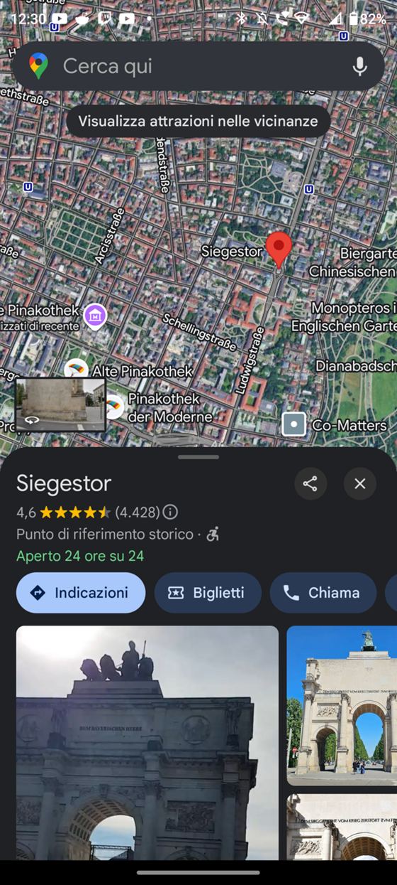

Button to find attractions near you and photos for the POI that user selected

**ExplorR**

|  |  |  |
| --- | --- | --- |
|  | **Reply to Questions** | **<- Questions to Ask** |
| **Mechanics** | Features an interactive real-time map with a "Fog of War" that clears as users move. Includes customizable 3D avatars, "Location Cards" for collecting places, and the ability to leave "memoirs" (photos/text) at specific POIs | What game elements are used? |
| **Dynamics** | Users are driven by spontaneous discovery; they must physically explore to reveal the map (remove the fog) and collect memories to build a "mental picture" of the location's history. Social dynamics allow sharing journeys and viewing friends' memoirs | How do users interact with these mechanics? |
| **Aesthetics** | Evokes a "magical moment" of connecting with a location's soul. It utilizes a narrative frame (e.g., exploring Earth in the year 2300) to create a "Pokemon-Go-like" experience that feels like a video game extension of the real world | What feelings or experiences are evoked? |
| **Target Audience** | Travelers engaging in spontaneous trips who dislike strict planning/guided tours. It serves both B2C (individual tourists) and B2B (outdoor facilities) markets | Who are the users? |
| **Purpose / Domain** | Location-Based Social Network / Gamified Travel. To revolutionize tourism by encouraging users to discover places "far off the guided tours" and deepen connections between people and locations | What goal or problem does it address? |
| **Pain Points / Gaps** | Technical challenges in implementing the "fog of war" efficiently. Initial prototypes suffered from non-modular architecture. Requires complex backend support for real-time social features and photo storage | What’s missing or not working? |

**Open World Adventures**

|  |  |  |
| --- | --- | --- |
|  | **Reply to Questions** | **<- Questions to Ask** |
| **Mechanics** | A narrative-driven Real World Travel RPG using curated locations (manually built) and "unverified" automated locales. Features include step counting, achievements, and "quest-like" city exploration | What game elements are used? |
| **Dynamics** | Mimics Open World Video Game logic in a real city. Users "buy into" the role-playing aspect to explore curations. The developer interacts directly with the community to prioritize city builds (e.g., Florence) | How do users interact with these mechanics? |
| **Aesthetics** | Aims for high immersion and depth, simulating a sandbox RPG environment. However, the current "v1" state is described as potentially "overwhelming" due to high complexity | What feelings or experiences are evoked? |
| **Target Audience** | Gamers, local gaming communities, and users looking for a "large-scale, open-world sandbox" experience applied to real-world travel | Who are the users? |
| **Purpose / Domain** | Gamified Tourism / RPG. To allow users to explore their city as if it were an open-world video game, focusing on narrative depth | What goal or problem does it address? |
| **Pain Points / Gaps** | Scalability issues: Manual curation of locations "slows it down." Complexity: The "v1" is described as "rough" and potentially too complex/overwhelming. Accessibility: Issues with device support (e.g., older Android phones) and difficulty gathering user feedback | What’s missing or not working? |

**Atlas Obscura**

|  |  |  |
| --- | --- | --- |
|  | **Reply to Questions** | **<- Questions to Ask** |
| **Mechanics** | A collaborative database of "hidden wonders" and curious locations. Users can "Add a Place," mark locations as "Been There" or "Want to Go," and create custom lists. It relies on editorial articles and user-generated entries rather than game loops. | What game elements are used? |
| **Dynamics** | Users interact by reading editorial content to discover oddities, then physically traveling to coordinates to satisfy curiosity. The dynamic is one of a "catalogue" or "checklist" rather than an active game; discovery is driven by narrative interest rather than XP or rewards. | How do users interact with these mechanics? |
| **Aesthetics** | Evokes Curiosity, Wonder, and Mystery. It focuses on the "weird," the macabre, and the overlooked (hidden gems), creating a literary and feeling of being an "insider" or "explorer" rather than a typical tourist. | What feelings or experiences are evoked? |
| **Target Audience** | "Anti-tourists," curious travelers, urban explorers, and history buffs who specifically want to avoid "tourist traps" in favor of unique, offbeat, or obscure history. | Who are the users? |
| **Purpose / Domain** | Digital Magazine / Collaborative Guide. To create a comprehensive community-driven guide to the world's most wondrous and unusual places that aren't found in standard guidebooks. | What goal or problem does it address? |
| **Pain Points / Gaps** | Lack of Gamification: It is primarily a consumption experience (reading/visiting) without feedback loops like leveling or badges. Navigation: It is a guide, not a navigation tool; users often need external apps (like Google Maps) to actually find the spots. | What’s missing or not working? |

Technology

## Flutter

The application is developed on the Flutter framework in its programming language *Dart*, the supported platforms on which the application is deployed are listed below.

## Android

Primary focus of development and use case of the application.

## Web on Wasm

Secondary use cases are being used in a web environment, granting powerful portability and accessibility.

## OpenStreetMap

For the map component OpenStreetMap is used for displaying and adapting its content for the application.

Modality

The urge of creating different game modes comes from the adaptation to different types of tourist. In fact we can have a tourist that only wants to visit a city with a little level of gamification, and others that want an immersive experience.

The main difference between the modes lies in how the map and the POIs are visualized.

# **Treasure hunt [To be implemented]**

The user cannot see the city map, as it is obfuscated. To find the Points of Interest (POIs), the user must follow the compass or other directions.

For each POI found, the user must complete a quiz. After successfully completing it, they earn XP and unlock a portion of the map.

# **Free Visit**

In this mode, question marks appear at the locations of the POIs, along with the number of XP that can be earned once the user unlocks them.

The XP and Quiz system is the same as theTreasure hunt mode.

# **Custom Town Visit [To be implemented]**

The user with initial customization questions can create a custom visit, choosing what type of POI want to visit

# **Cooperative [To be implemented]**

The user has the option to join and invite other players to their own experience, also gaining more rewards

Game rules

XP System

A user can obtain XP (experience points) in one way: completing quizzes available on POIs available throughout the city.

Answering a quiz provides different amount of XP based on user knowledge:

* 25 XP if the player answers the quiz correctly at the first try
* 10 XP if the player has no tries left, or if it answers within 3 tries

# Level System

Users start from level 1 and can level up gaining XP.

Right now, eight levels are available and each one requires 125 XP to level up.

# Badges System

Users can unlock badges satisfying certain conditions, these are seen as achievements.

Right now, five badges can be unlocked:

* “The First POI” badge: unlockable visiting for the first time a POI;
* “The Explorer” badge: unlockable visiting for the first time 10 POIs;
* “The Adventurer” badge: unlockable visiting for the first time 25 POIs;
* “The Traveler” badge: unlockable visiting for the first time 50 POIs;
* “The Globetrotter” badge: unlockable visiting for the first time 100 POIs;

# Gems System

Gems are a free-to-play in-game currency and they can be earned through the following rule:

* When two POIs are visited then one gem is assigned

# Cosmetics System

Users can unlock cosmetics in two ways:

* Levelling up: every two levels, the user unlocks a cosmetic;
* Buying them in the store with Gems (free-to-play in-game currency) [to be implemented]

# Leaderboard System

Available leaderboards (global, local and friends, the last two are not implemented yet), resets every week [to be implemented]

Mechanics

Everyone plays their own visit/exploration, but it's possible to join the ones of other players for a cooperative experience.

**Profilation [Future Implementation]**

During its use the application will ask the user a few questions in order to profile them.

The questions to be asked are:

## **On initial start-up**

### **Would you like to stay green? yes/no**

### **Would you like to be suggested restaurants and attractions during your visits?**

* Yes
* Only restaurants
* Only attractions
* No

The user will still be capable of changing their preferences freely in the settings page.

## **During a visit**

### **How are you faring?**

* I'm still raring to explore
* I'm okay
* I'm tired

### **Do you want to walk less between two points?**

* No
* yes

# **Navigation**

The main mechanic is navigating through the visit/exploration map by following the different instructions/challenges proposed to the user.

## **Visit settings**

Before starting a visit, personalization options will be available to be selected, allowing the player more freedom of choice

### **How many methods of transportation are you willing to use? [Multiple options]**

* Walk
* Bike
* Car
* Bus
* Underground

### **Do you prefer closed areas or open areas?**

* Both
* Closed
* Open

### **Gamemode:**

* Treasure Hunt **[Future implementation]**
* Free visit
* Custom visit **[Future implementation]**
* Cooperative **[Future implementation]**

## **Compass**

A compass may pop up on the screen, pointing to the next point of interest to discover. The compass can also be integrated with a recommender system (ML) that guides the user to the most suitable POI according to it's taste.

## **Map**

The map can be brought up at any point in the navigation and is initially obfuscated. The user, unlocking the various POI, can see the various parts of the location of the navigation.

This feature can change, in fact the user can choose between two modes, described in Game Modes, so in one case the user can see the entire map, in the other, which is talked about here, normal play style is with the obfuscated map.

# **Hints [Future implementation]**

A hint may pop up for the following reasons:

* nothing is being done during the navigation
* an eligible POI is near
* A hinted POI is not being found

the hint may be a riddle, a suggestion to look elsewhere, an indication, or a question.

The hints will refer to monuments/places that the users already know for different reasons:

* being around the hinted objects near a POI
* being around the hinted objects for a certain amount of time during the visit

# **Quiz**

A quiz may pop up for the following reasons:

* A hidden challenge is found **[Future implementation]**
* A hinted object is found **[Future implementation]**
* A location is discovered

The question is related to the current activity of the player and its difficulty is adjusted depending on their level and perceived knowledge of the topics.

The answer is selected from a multiple choice of possible answers.

Each quiz has 3 attempts, after which the correct answer is highlighted and the exploration continues, for each wrong answer the XP and gems that can be earned from the quiz decrease linearly.

Some quizzes may be used to further profile the user, for example, if a user answers correctly in a specific topic, they'll be more likely to be directed to related POIs.

# **POI Unlock**

The user may unlock a POI by completing one of the following actions:

* Completing a quiz successfully
* Scanning a physical QR Code **[Future implementation]**

If the user interacts with physically present QR Codes in some points of interests, scanning them would unlock the corresponding area on their map, earning XP.

### **Side Quests [Future implementation]**

After a POI is unlocked and so a part of the map revealed, the map can show other POI were the user can go, do a quiz and earn XP. We call these secondary POIs "Side Quests"

# **Hidden POIs [Future implementation]**

Sometimes users may find hidden points of interest that are not listed or shown in the map.

Detailed information about the discovered POIs may pop up in order to supplement the visit.

The **Hidden POI** mechanics are the same as those of a normal POI.

Some well hidden POI, if unlocked, can give the user more XP than usual, as well as unlocking new badges for their profile.

# **Difficulty levels [Future implementation]**

A Duolingo-like level-based system is employed: as you learn more, the difficulty of the questions increases and you’re also tasked with recalling notions you’ve learned previously.

This mechanic is introduced to increase the level of information given to the user based on their skills. If our user is pretty much skilled then we shouldn't bore him with easy questions that should be belonging to rookies.

Progression

For each important event and interaction the user will be awarded XP and gems.

**XP** can be earned by:

* Discovering a POI hidden **[Future implementation]**
* Guessing a quiz correctly
* Following a hint (towards an hidden POI) successfully **[Future implementation]**
* Accepting a recommendation for restaurants or attractions **[Future implementation]**

**Gems** can be earned:

* Guessing certain quiz correctly
* Leveling up

# **Currency**

Gems are used to buy optional content in the application, such as cosmetics, or hints and help in exploration.

# **Experience Levels**

By earning enough XP the user can level-up.

The amount of XP to be earned for the next level-up doesn't increase between levels.

For each level the user may unlock relevant features or collectibles

# **Cosmetics**

In our system when a user levels up, they can obtain a cosmetic that can be equipped and shown in their own profile.

Additionally, cosmetics may be bought with gems.

**Badges system**When a user accomplishes a goal (i.e. visiting a gothic church for the first time), it obtains a badge that can be shown as a representative badge in their profile. Also, badges are available on a specific page for consultation.

Game loop

Core loop

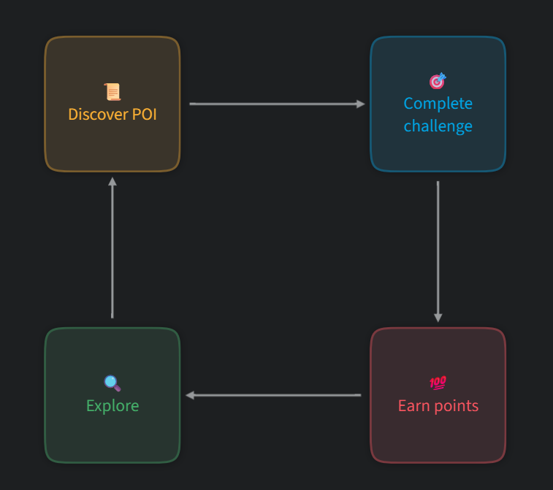

The core loop is centered around exploring the selected City in order to discover the various Points of Interest that it has to offer, after a POI is found a challenge will be asked to be completed, earning points will then encourage to continue exploring and repeat the loop.

# Game flow

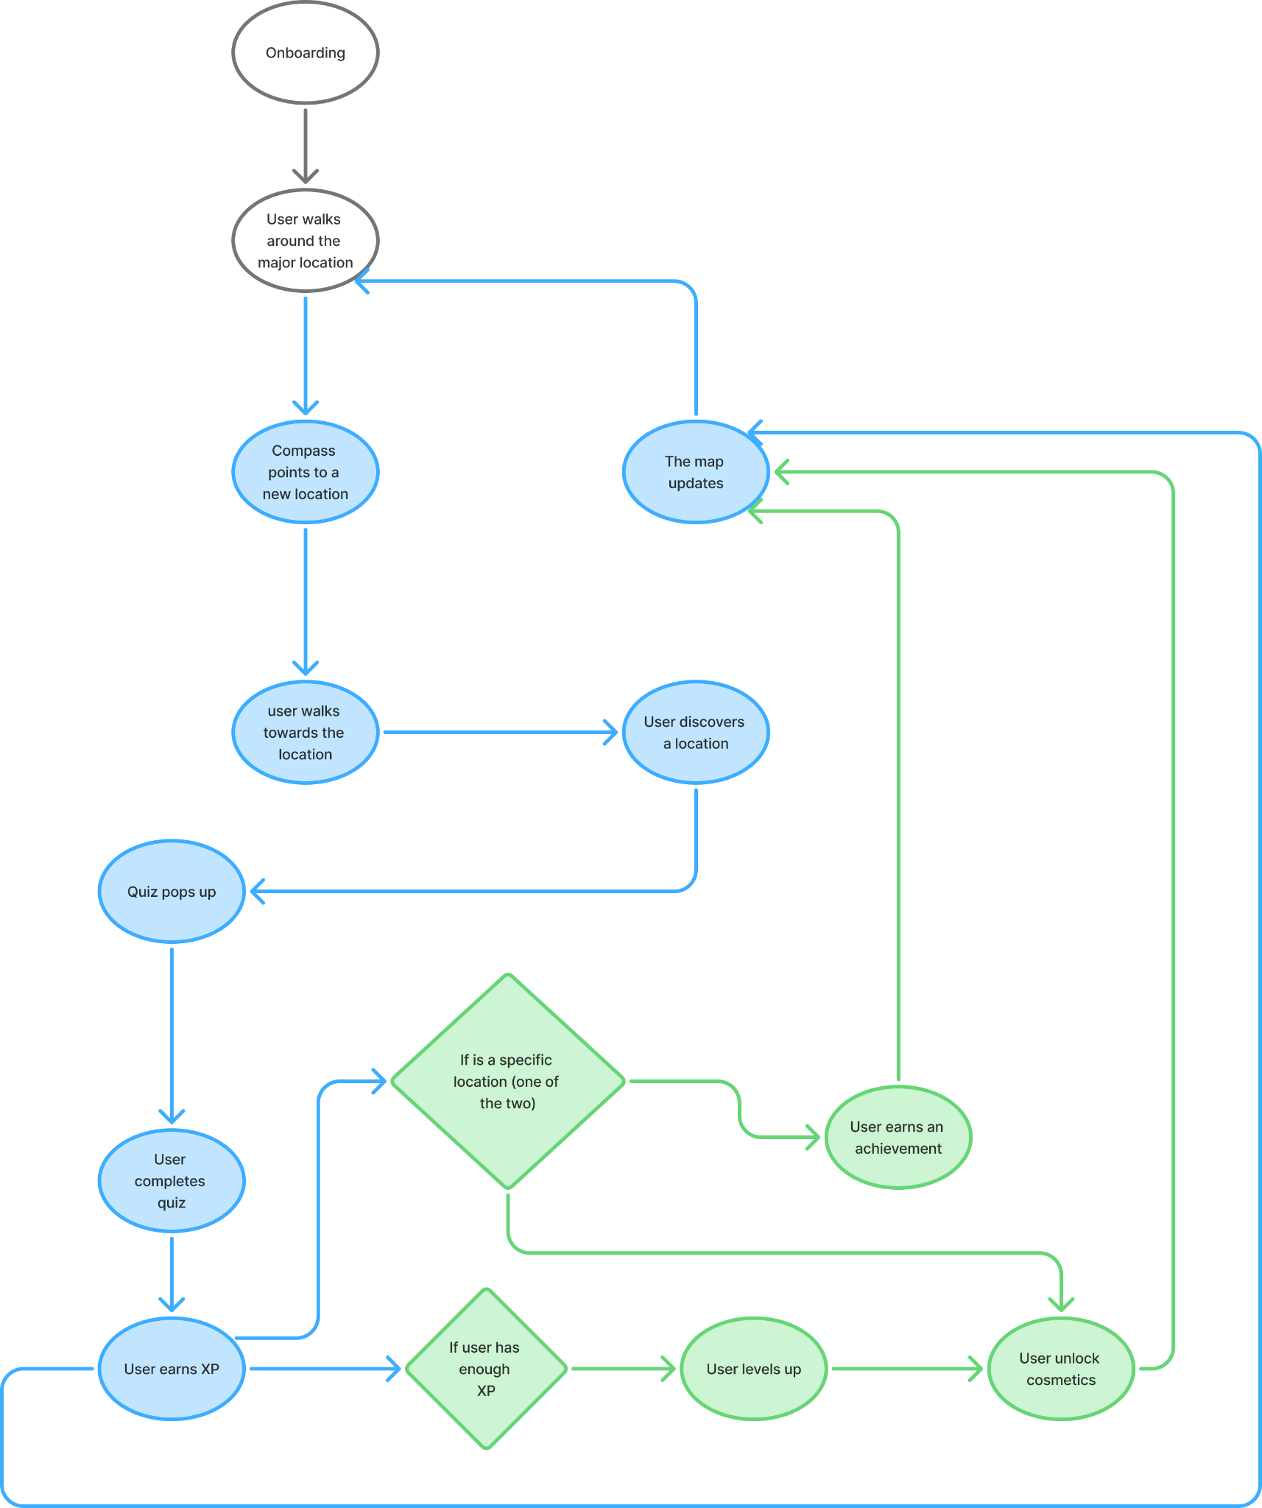

The entire application is based on:

* when an POI is found, a quiz will pop up
* when a user levels up the application will report that they unlocked new cosmetics
* The compass pointing to a POI will ease the user in looking for it

**[Future Implementation]**

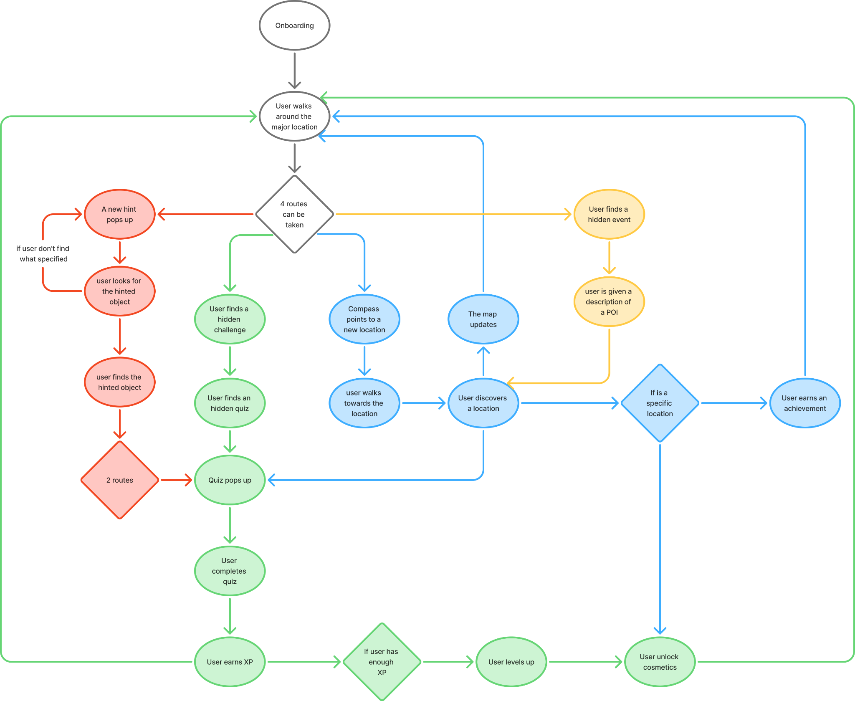

As shown, the user has many interaction (and non!) choices that lead to avenues stimulating the usage of the entire application:

* If the user selects a City but does nothing, a hint will pop up in order to encourage him to engage
* when an objective relative to a hint is found, a quiz will pop up
* when a user levels up the application will report that they unlocked new cosmetics
* The compass pointing to a POI will ease the user in looking for it

Gamification elements

# Quizzes

Used for unlocking POIs, they serve the purpose of being the primary source of XP and gems

# Leveling system

The user can level up, and by doing so unlock various features and rewards

# Gem system

The user can also choose to unlock features and rewards by spending gems, earned throughout the application

# Leaderboard

A metric of comparison between players is offered, with various classifications and regional leaderboards.

# Cosmetics

esthetic elements to be equipped by players to get them to be and feel distinct to each other

# Badges

Milestones and achievements that will forge a unique path/experience for each player

# 

Performance

# Acknowledgement

* **Badges:** unlockable under several conditions (often performing a precise sequence of actions), are literally a trophy section for the user
* **Cosmetics:** unlockable when the user levels up, but they can also be purchased with gems. The user can also unlock them finishing rare events or finding Hidden POIs [to be implemented]

# Level

* **User levels:** every time a user answers correctly a quiz, gains a certain amount of experience points that allows him/her to level up and unlock badges or cosmetics

# Progression

* **Map Unlocking (Spatial)**: The application uses an obfuscated map that is initially hidden. As users discover Points of Interest (POIs) and complete quizzes, they unlock portions of the map, providing immediate visual feedback on their physical advance through the city and allowing them to locate themselves within the revealed territory [to be implemented]
* **Progress Bars (Visual)**: Extrinsic guidance is provided via XP progress bars displayed in the Profile and feedback pop-ups, indicating how close the user is to the next Experience Level
* **Session Counters (Steps)**: The HUD includes specific counters (e.g. "0/5 visited places") to track the completion of the current exploration session

# Point

* **Experience Points (XP)**: These represent progression. XP is earned by discovering Points of Interest (POIs), completing quizzes, and following hints. Accumulating XP allows users to level up
* **Gems (Currency)**: These act as a spendable resource. Gems are earned alongside XP and are used to purchase cosmetics for profiles or to buy hints during difficult navigation challenges.

# Stats

* **Profile Dashboard**: This acts as the central hub for data, displaying the user's current Level, an XP progress bar, Precision (percentage of correct answers), total Correct Answers, Visited Places, and the count of Unlocked Badges,.
* **Weekly Statistics**: A dedicated section reports the player’s experience and performance metrics specifically for the current week of usage [to be implemented]
* **Activity HUD**: Upon completing specific actions (like a quiz), the interface displays immediate, session-based stats such as XP Gained and other stats
* **Map HUD**: the user can see the the level, the total number of gems, and the XP gained in the current session

Ecological

# Economy

* **Gems trading:** virtual currency earned via quizzes and leveling up. Users trade gems to obtain functional advantages, specifically hints to solve riddles or navigation aid and to purchase aesthetic cosmetics for their profile

# Rarity

* **Hidden POIs / Rare Badges / Customizables**: These items are extrinsically limited because they are locked behind specific difficult conditions or are designed to be "sparse and specific" to increase their perceived value and stimulate user desire [to be implemented]

# 

Social

# Competition

* **Leaderboards:** The application utilizes global and local leaderboards that serve as a metric of comparison between players. These leaderboards are designed to reset every week to maintain engagement

# Cooperation

* **Cooperative Game Mode:** A dedicated "Cooperative" mode allows users to join and invite other players to their own experience. In this mode, users interact with each other and can gain increased XP for collaborating [to be implemented]

# Reputation

* **Profile Customization:** Users can acquire "cosmetics" by leveling up or spending gems. These items allow users to customize their profiles, creating a distinction between players

Personal

# Novelty

The application incorporates novelty through Unpredictability and Curiosity, which are key drivers in its design. The environment avoids stagnation by using an obfuscated map that reveals new content and areas only as the user explores. To maintain engagement and surprise, the system includes "Hidden POIs" (Points of Interest) that are not listed on the standard map.

Additionally, the unlock of "Rare cosmetics" and "Rare badges" serves as unexpected rewards that change the user's status within the environment.

# Objectives

The user could have the goal of unlocking all the POIs suggested in the city (that’s because a user could decide to stop the visit whenever they want, even if only one POI was visited), willing to enrich his cultural learnings about the city.

# Puzzle

* **Quizzes**: The primary mechanism for interaction is a Quiz that pops up when a user discovers a POI. These questions are related to the user's current activity and location, and the difficulty adjusts based on the user's skill level [skill level to be implemented]
* **Riddles**: The "Hints" system may present information in the form of a riddle, requiring the user to solve a cognitive task to locate the next POI objective [to be implemented]

# Renovation

* **Second Chances**: When facing a quiz, the user is granted *n* attempts to select the correct answer before the opportunity concludes
* **Boosts**: Users can utilize Gems to purchase hints and help in exploration effectively allowing them to boost their performance or overcome difficult tasks

# Sensation

* **Navigation Tools**: The *Compass* and the *Map* serve as dynamic visual interfaces that guide the user's physical movement through the city

Fictional

# Storytelling

* **Visual Resources**: The obfuscated map fog of war visually represents the narrative concept of the Abyss, showing darkened areas that the user must physically unlock and illuminate

Feedback

The application contains different variations and types of feedback:

## Quiz completion

When the player answers a quiz, they get informed of the correctness of their choice, highlighting it with a negative color if wrong and with a positive one if correct. Eventually the correct choice will be shown in any case.

**timing**: immediate

**content**: corrective/reporting

## Map position

When navigating through the map the player knows where they are by having at their disposal a marker signaling their position.

**timing**: constant

**content**: reporting

## Notifications **[Future implementation]**

The application can send notifications for various purposes, e.g. reporting new software updates, announcements, reminders. Letting the user know about content in the application even while not using it.

**timing**: late

**content**: reporting

## Gems and XP earned

Throughout the experience the application reports the events of earning gems and XP and the earned quantity, scenarios of this feedback include: unlocking a POI, answering a quiz, actively following hints/compass/directions.

**timing**: immediate

**content**: reporting

## Player statistics

The application has a dedicated section reporting all the relevant statistics describing the player’s experience in the current week of usage.

Statistics displayed are:

* Number of correct answers
* Accuracy of completed quizzes
* Number of visited places (POIs)
* Number of unlocked Badges

**timing**: delayed

**content**: reporting

Dynamics

# Curiosity

Users feel a sense of mystery and a compulsion to "illuminate" the city, driven by the visual feedback of the obfuscated map [obfuscation to be implemented]. Instead of following a fixed route, the dynamic creates "spontaneous discovery," where users physically explore to reveal the map and remove the "Abyss" influence.

# Social interaction

Users can group together to visit city’s POIs in order to maximize the XP gain by learning faster and try to answer correctly quizzes

# Intergenerational collaboration

In family groups, a "co-guided" dynamic emerges where different generations assume different roles: teenagers manage the digital gamified elements (badges, XP), while older adults (parents/grandparents) focus on the cultural content and learning

# Competitive spirit

The two implemented leaderboards, one for visited POIs and one for the amount of XP gained throughout the gameplay, feeds the desire of rising their position in the leaderboard, competing with other players

# Habit formation

The system encourages a "return-trigger" dynamic through the use of weekly statistics and leaderboards that reset every week. This prevents the leaderboard from becoming stagnant and motivates users to maintain their performance week-over-week to rise in the global rankings.

# Scarcity and Insider status

By including Hidden POIs [to be implemented] that do not appear on the standard map, we create a "treasure hunt" dynamic. This shifts the user from a passive tourist to an active explorer or insider, as finding these rare locations and badges increases their perceived status and validates their curiosity

Game Aesthetics

HomePage

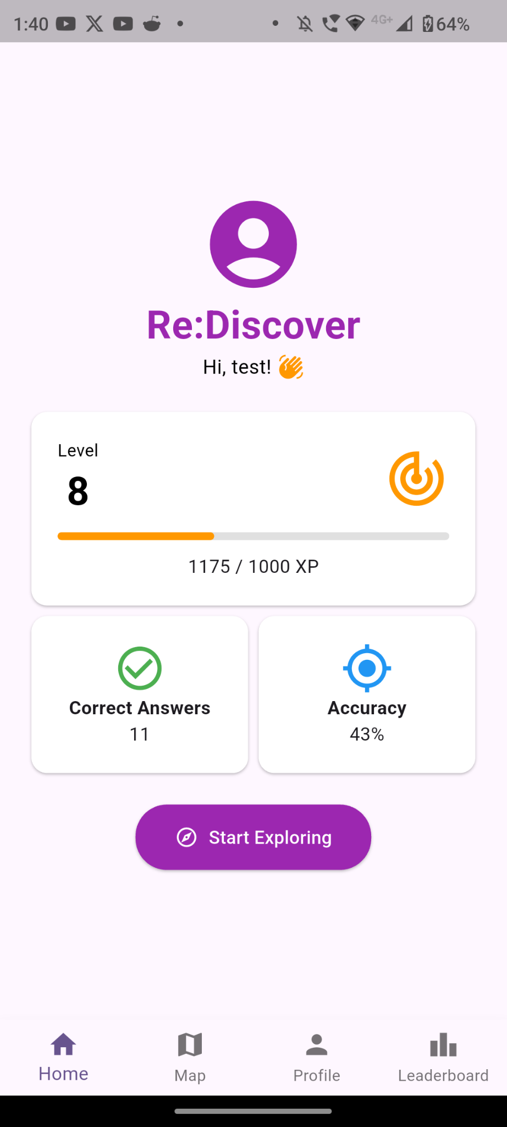

Profile Page

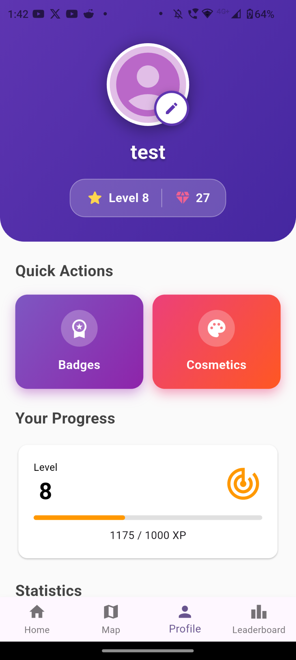

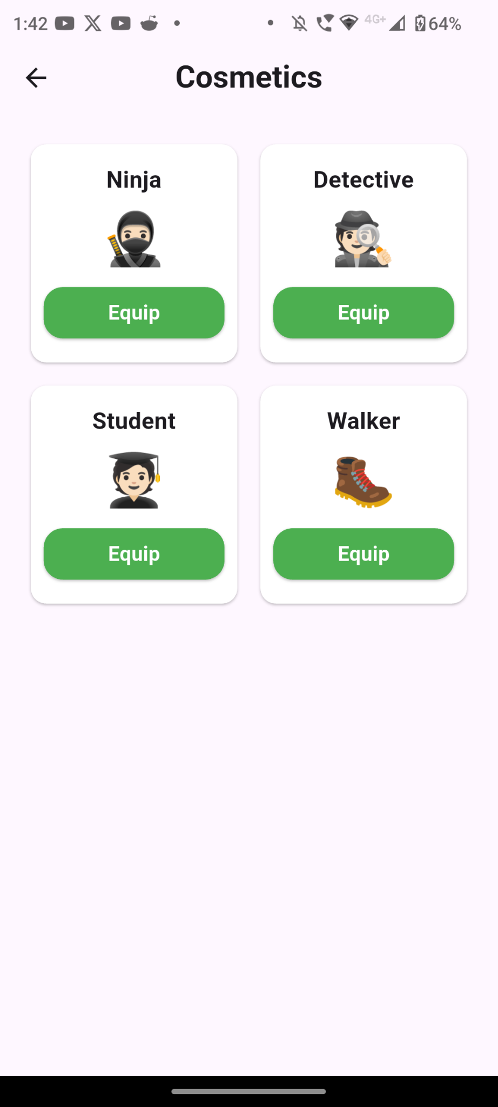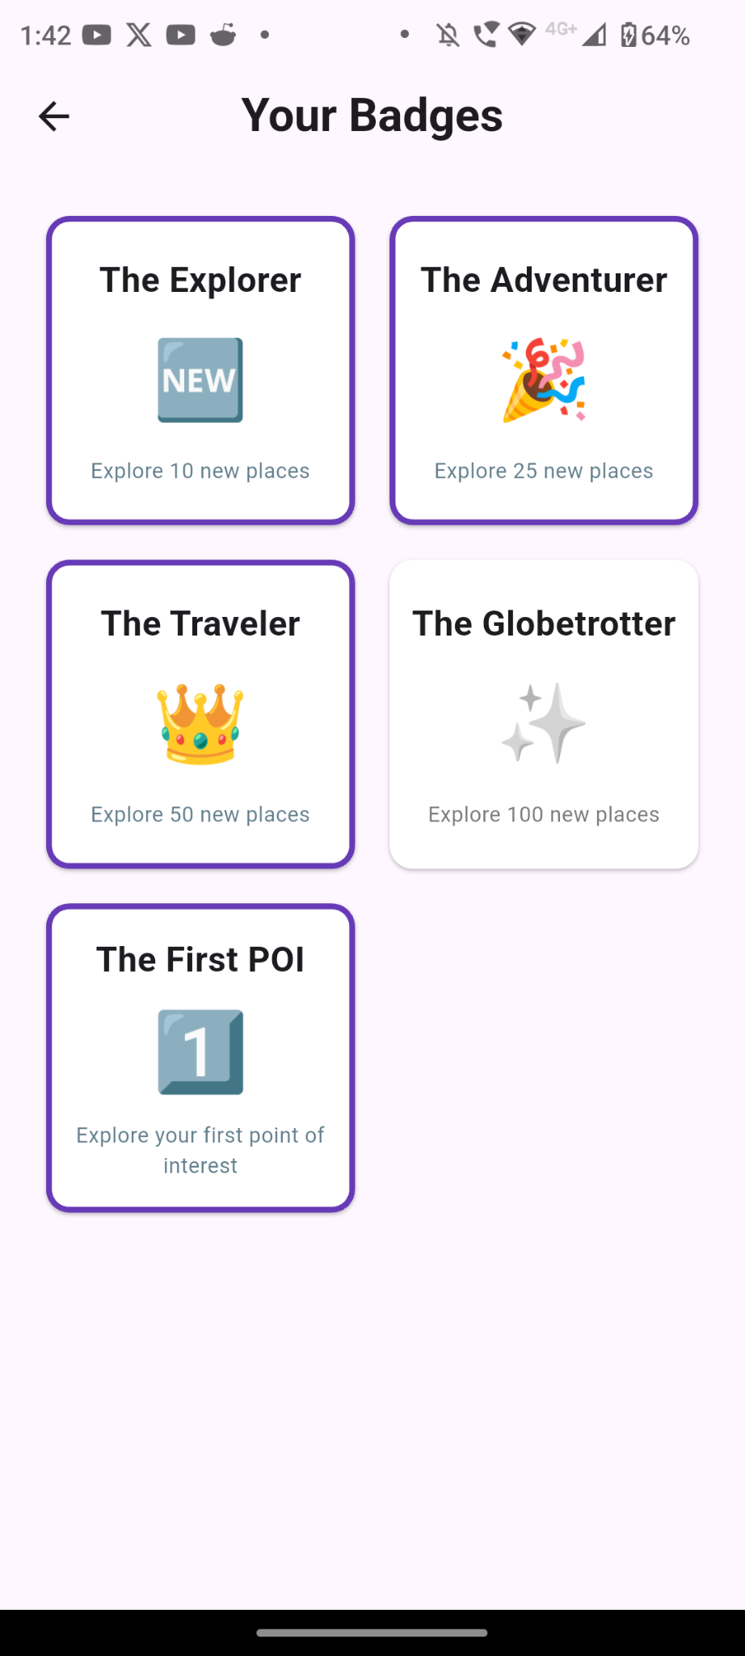

Map Page

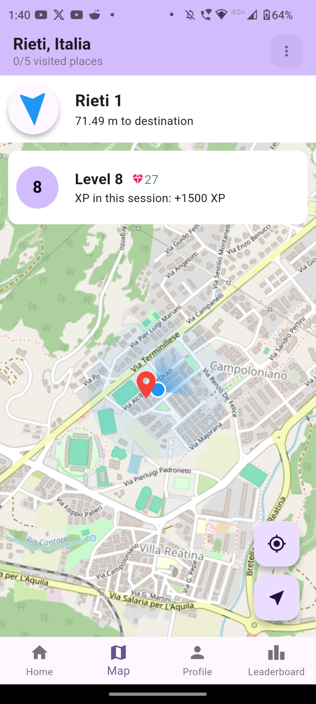 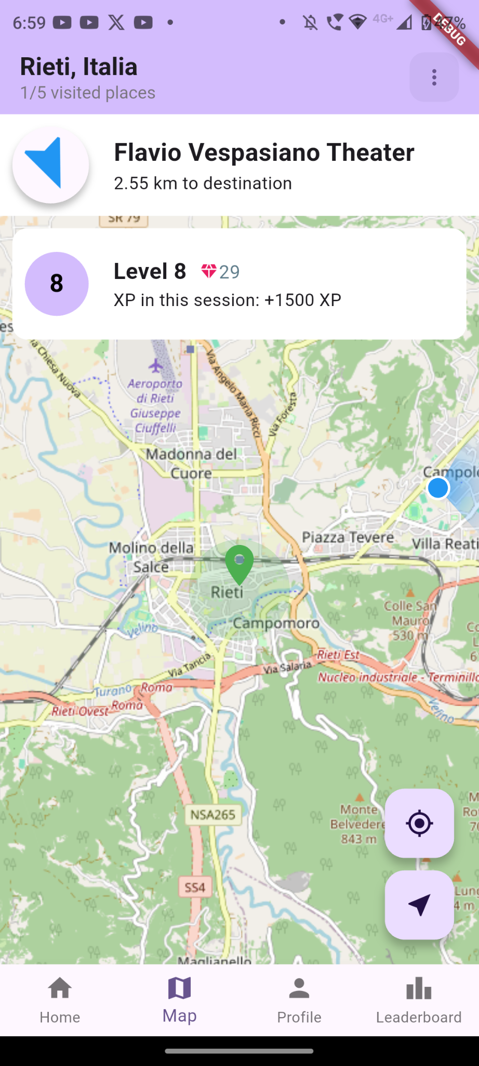

POI View

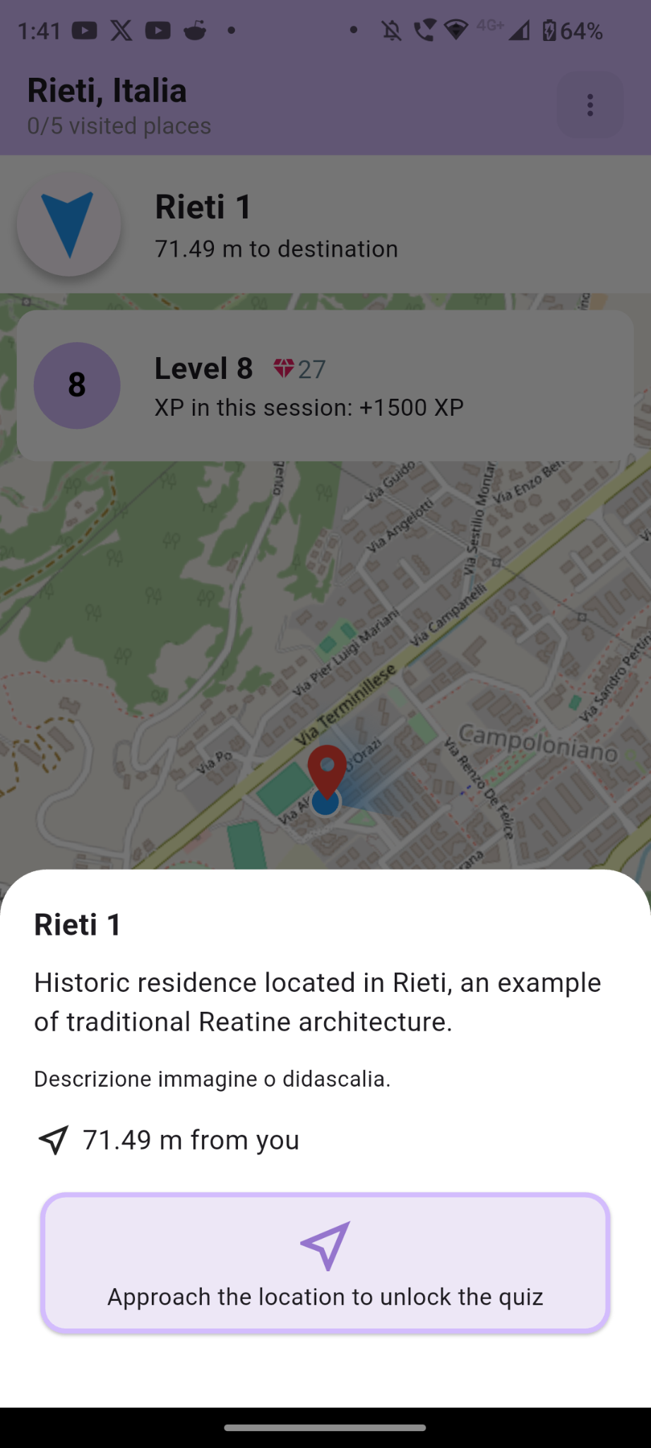 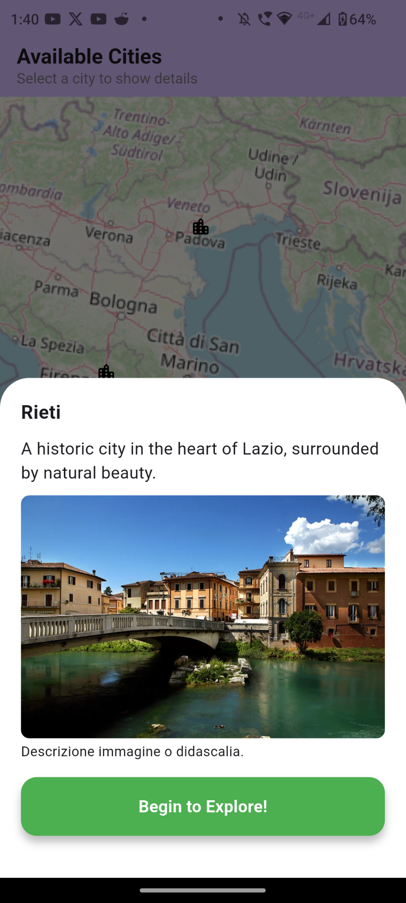

Quiz Screen

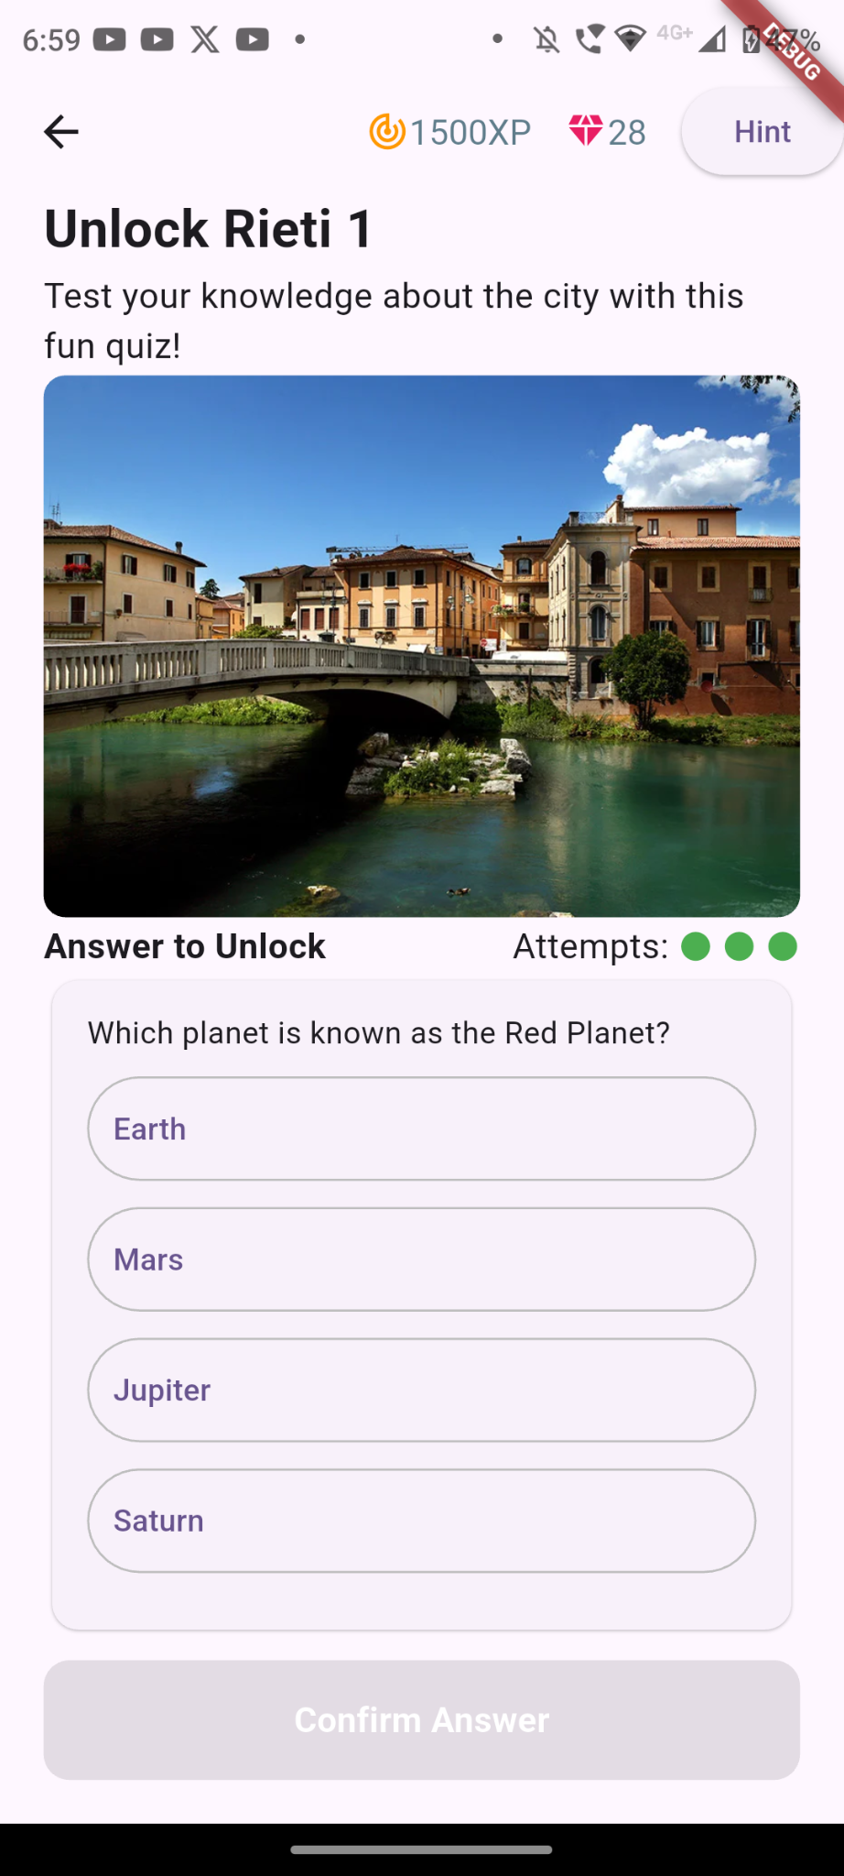

Rewards Screen

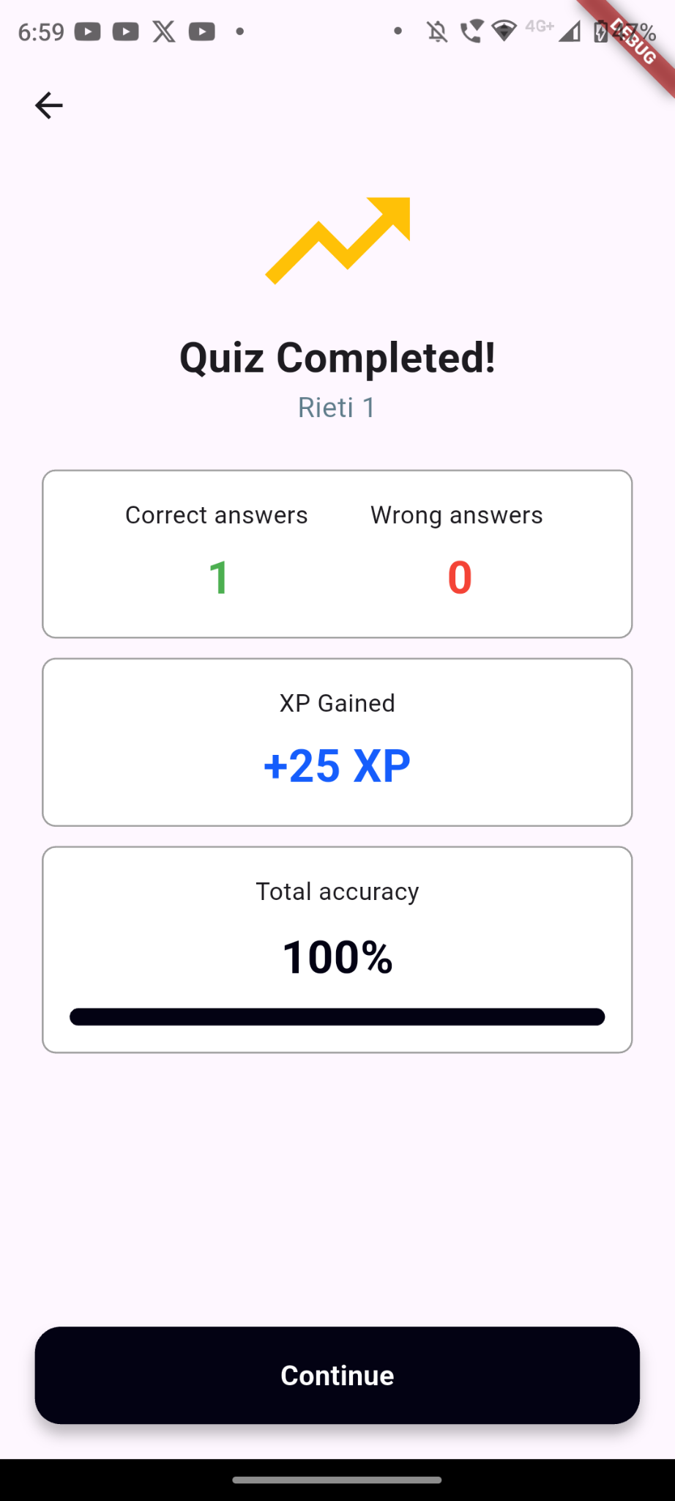

Leaderboard

